**KHELO-MATE**

**A Project Report Submitted**

**in Partial Fulfillment of the Requirements**

**for the Degree of**

**MASTER OF COMPUTER APPLICATION**

**by**

**AMAN KUMAR SHARMA**

**(University Roll No. 2200290140025)**

**AMAN CHAUDHARY**

**(University Roll No. 2200290140022)**

**ABDUL WALI KHAN**

**(University Roll No. 2200290140004)**

**Under the Supervision of**

**Ms. Divya Singhal**

(ASSOCIATE PROFESSOR)



**Submitted**

**to the**

**Department Of Computer Applications**

**KIET Group of Institutions, Ghaziabad**

**Uttar Pradesh-201206**

**DR. APJ ABDUL KALAM TECHNICAL UNIVERSITY (Formerly Uttar Pradesh Technical University) LUCKNOW**

**(MAY, 2024)**

**CERTIFICATE**

Certified that **Aman Kumar Sharma (2200290140025), Aman Chaudhary (2200290140022)** and **Abdul Wali Khan (2200290140004)** has carried out the project work having “Khelo - Mate” (**Final Project KCA-451**) for **Master of Computer Application** from Dr. A.P.J. Abdul Kalam Technical University (AKTU**)** (formerly UPTU), Lucknow under my supervision. The project report embodies original work, and studies are carried out by the students themself and the contents of the project report do not form the basis for the award of any other degree to the candidate or to anybody else from this or any other University/Institution.

**Date: 20-MAY-2024**

**AMAN KUMAR SHARMA (2200290140025)**

**AMAN CHAUDHARY (2200290140022)**

**ABDUL WALI KHAN (2200290140004)**

This is to certify that the above statement made by the candidate is correct to the best of my knowledge.

Date: 20-MAY-2024

**Ms. Divya Singhal Dr. ARUN TRIPATHI**

**Associate Professor Head**

**Department of Computer Department of Computer Applications Applications**

**KIET Group of Institutions, KIET Group of Institutions,**

**Ghaziabad Ghaziabad**

**AMAN KUMAR SHARMA**

**AMAN CHAUDHARY**

**ABDUL WALI KHAN**

**ABSTRACT**

This project report presents Khelo Mate, a comprehensive web application developed using the MERN (MongoDB, Express.js, React, Node.js) stack, designed to revolutionize the engagement of sports enthusiasts with their favorite activities. The primary objective of Khelo Mate is to provide a centralized, user-friendly platform that integrates event discovery and registration, venue booking, team and player management, social networking, personalized recommendations, coaching and training resources, and community building.

The application addresses the fragmented nature of existing sports engagement solutions by consolidating all essential features into one cohesive platform. Users can easily find and register for sports events, book venues, manage teams and player profiles, and connect with other sports enthusiasts. The personalized recommendation system, powered by advanced algorithms, ensures users receive relevant suggestions based on their preferences and past activities. Additionally, Khelo Mate offers valuable coaching and training resources, further enhancing the user's sports experience.

The development of Khelo Mate leverages the MERN stack to ensure scalability, security, and performance. MongoDB provides a flexible and scalable database solution, while Express.js and Node.js offer a robust and efficient backend framework. React is utilized for building a responsive and interactive user interface, ensuring a seamless user experience across various devices.

**ACKNOWLEDGEMENTS**

Success in life is never attained single-handedly. My deepest gratitude goes to my project supervisor, **Ms. Divya Singhal** for his guidance, help, and encouragement throughout my project work. Their enlightening ideas, comments, and suggestions.

Words are not enough to express my gratitude to **Dr. Arun Kumar Tripathi**, Professor and Head, Department of Computer Applications, for his insightful comments and administrative help on various occasions.

Fortunately, I have many understanding friends, who have helped me a lot on many critical conditions and my team partner to develop the entire project alongside.

Finally, my sincere thanks go to my family members and all those who have directly and indirectly provided me with moral support and other kind of help. Without their support, completion of this work would not have been possible in time. They keep my life filled with enjoyment and happiness.

**AMAN KUMAR SHARMA**

**AMAN CHAUDHARY**

**ABDUL WALI KHAN**

**TABLE OF CONTENTS**

Page No.

Certificate i

Abstract ii

Acknowledgement iii

List of Tables vi

List of Figures vii

**CHAPTER 1: INTRODUCTION** 1-13

* 1. Need of Khelo Mate
  2. Objectives
  3. Even Discovery And Registration
  4. Detailed Event Information
  5. Venue Booking
  6. Real Time Availability and Pricing
  7. Team and Player Management
  8. Team and Management Tools
  9. Project Scope
  10. Hardware/Software used in Project

**CHAPTER 2: FEASIBILITY STUDY** 13

2.1 Technical Feasibility

2.2 Operational Feasibility

2.3 Behavioral Feasibility

2.4 Schedule Feasibility

**CHAPTER 3: DATABASE DESIGN** 14-21

3.1 Database Tables

3.2 Flowchart

3.3 Use Case Diagram

3.4 Data Flow Diagram

**CHAPTER 4: TECHNOLOGY** 22-24

4.1 Node Js

4.2 Express

**CHAPTER 5: FORM DESIGN** 15-32

5.1 Administrative Modules

**CHAPTER 6: TESTING** 33-34

6.1 Test Case-1

6.2 Test Case-2

Bibliography 35

**LIST OF TABLES**

|  |  |  |
| --- | --- | --- |
| **Table No.** | **Name of Table** | **Page No.** |
| 3.1 | Users Table | 16 |
| 3.2 | Chat Table | 17 |

**LIST OF FIGURES**

|  |  |  |
| --- | --- | --- |
| **Fig. No.** | **Name of Figure** | **Page No.** |
| 3.1 | Database Design | 14 |
| 3.2 | MongoDB | 15 |
| 3.3 | User | 16 |
| 3.4 | Message | 17 |
| 3.5 | Flowchart | 18 |
| 3.6 | Use Case Diagram | 19 |
| 3.7 | Data Flow Diagram | 21 |
| 4.1 | Npm Js Dashboard | 23 |
| 5.1 | User select Register/Login | 27 |
| 5.2 | User Registration | 28 |
| 5.3 | Correct Credentials | 29 |
| 5.4 | User Dashboard | 30 |
| 5.5 | Create Chat | 31 |
| 5.6 | Save Chat | 32 |

**CHAPTER -1**

**INTRODUCTION**

Khelo Mate is an innovative web application designed to streamline and enhance the way sports enthusiasts engage with their favorite activities. By providing a comprehensive hub for managing, discovering, and participating in sports events, Khelo Mate caters to a diverse audience ranging from casual players to professional athletes. The platform's key features include event discovery and registration, venue booking, team and player management, social networking, personalized recommendations, coaching and training resources, and community building. This project report delves into the detailed functionalities, benefits, and vision of Khelo Mate, highlighting its potential to revolutionize sports engagement.

**1.1** **The Need for Khelo Mate**

In today’s fast-paced world, finding and participating in sports activities can be challenging. Sports enthusiasts often face difficulties in discovering events, booking venues, managing teams, and connecting with other players. Existing solutions are fragmented, requiring users to navigate multiple platforms and services. Khelo Mate addresses these challenges by offering a centralized platform that integrates all essential features, making sports engagement seamless and enjoyable.

**1.2 Objectives**

The primary objectives of Khelo Mate are:

- To provide a user-friendly platform for discovering and registering for sports events.

- To simplify the process of booking sports venues.

- To offer robust tools for team and player management.

- To foster a vibrant community of sports enthusiasts through social networking features.

- To deliver personalized recommendations for events and activities.

- To provide access to coaching and training resources.

- To promote community building through social events and discussions.

**1.3 Event Discovery and Registration**

Khelo Mate’s event discovery feature allows users to easily find sports events happening in their locality or beyond. The platform provides detailed information about each event, including schedules, venues, and entry requirements. Users can filter events based on their preferences, ensuring they find activities that suit their interests. The registration process is streamlined, enabling users to sign up for events quickly and efficiently.

**1.4 Detailed Event Information**

Each event listed on Khelo Mate includes comprehensive details such as:

- Date and time

- Venue location with maps

- Entry fees

- Event description and rules

- Contact information for organizers

**1.5 Venue Booking**

The venue booking feature is designed to simplify the process of reserving sports facilities. Users can access real-time information on the availability and pricing of various venues, making it convenient to plan their activities. This feature is particularly beneficial for both individual players and teams, ensuring they have access to quality facilities when needed.

**1.6 Real-Time Availability and Pricing**

Khelo Mate provides up-to-date information on:

- Available time slots

- Pricing details

- Facility amenities

- Booking policies and terms

**1.7 Team and Player Management**

Khelo Mate offers robust tools for team and player management. Users can create and manage sports teams, track performance metrics, and maintain effective communication with team members. Individual players can develop profiles showcasing their skills, achievements, and participation history, serving as a digital resume for sports enthusiasts.

**1.8 Team Management Tools**

The platform includes features such as:

- Team creation and roster management

- Performance tracking and statistics

- Messaging and communication tools

- Schedule and event management

**1.9 Social Networking**

Integrating social networking features, Khelo Mate allows users to connect with other sports enthusiasts, share experiences, post updates, and follow other players or teams. This fosters a sense of community and enhances user engagement.

**1.10 Key social networking features include:**

- User profiles and activity feeds

- Friends and followers system

- Discussion forums and groups

- Photo and video sharing

**1.11 Personalized Recommendations**

Khelo Mate uses advanced algorithms to provide personalized event and activity recommendations based on user preferences and past behavior. This ensures that users receive relevant suggestions, making their experience more tailored and enjoyable.

**1.12 Customization and Personalization**

The recommendation engine takes into account:

- User’s sports interests and preferences

- Past participation history

- Location and availability

- Peer and community trends

**1.13Community Building**

Khelo Mate promotes community building by organizing social events, tournaments, and meetups. It encourages participation in discussions, forums, and community-driven activities, creating a supportive and interactive environment for users.

**1.14Community-building initiatives include**:

- Organizing local and regional tournaments

- Hosting social events and meetups

- Facilitating discussions and forums

- Recognizing and rewarding active members

**1.15** **Target Audience**

Khelo Mate caters to a diverse audience, including:

- Casual Players: Individuals looking for recreational sports activities.

- Professional Athletes: Athletes seeking competitive events and professional development opportunities.

- Event Organizers: Organizations and individuals planning and managing sports events.

- Coaches and Trainers: Professionals offering coaching services and training programs.

- Sports Venues: Facilities offering rental services for various sports activities.

**1.16 Understanding the Users**

Each user group has unique needs and expectations, which Khelo Mate addresses through its comprehensive set of features and user-friendly design.

**Convenience**

Khelo Mate centralizes all sports-related activities, reducing the need to use multiple services and making the user experience more convenient.

**Engagement**

The platform enhances user engagement through interactive features and community involvement, encouraging users to stay active and connected.

**Skill Development**

With access to coaching resources and training opportunities, users can improve their skills and achieve their sports goals.

**Networking**

Khelo Mate facilitates networking among sports enthusiasts, allowing users to build connections, collaborate, and support each other.

**Community Impact**

By fostering a strong sense of community, Khelo Mate contributes to the overall well-being and social cohesion of its users, promoting a healthier lifestyle.

**Platform Architecture**

Khelo Mate is built using modern web technologies to ensure scalability, security, and performance. The platform employs a modular architecture, allowing for easy updates and integration of new features.

**1.17 User Interface Design**

The user interface is designed to be intuitive and accessible, providing a seamless experience across various devices. The design focuses on simplicity and functionality, ensuring that users can easily navigate and utilize the platform's features.

**Data Security**

Khelo Mate prioritizes data security and privacy, implementing robust measures to protect user information. This includes secure data storage, encryption, and compliance with relevant data protection regulations.

**Feature Enhancements**

Khelo Mate plans to continuously enhance its features based on user feedback and emerging trends in sports technology. Future updates may include advanced analytics, AI-driven insights, and enhanced social networking capabilities.

**Expansion and Growth**

As the user base grows, Khelo Mate aims to expand its reach by partnering with more sports organizations, venues, and coaches. The platform will also explore opportunities to enter new markets and regions.

**Community Initiatives**

Khelo Mate will continue to invest in community-building initiatives, fostering a supportive and active sports community. This includes organizing more events, expanding training resources, and enhancing user engagement features.

**1.18 Project Scope**

The scope of the Khelo Mate project encompasses the development and deployment of a web application designed to enhance sports engagement by providing a centralized platform for event discovery, venue booking, team and player management, social networking, personalized recommendations, and access to coaching and training resources. Utilizing the MERN stack (MongoDB, Express.js, React, Node.js), the project aims to create a robust, scalable, and user-friendly solution that caters to a wide range of users, from casual players to professional athletes

- Develop a comprehensive web application that integrates essential features for sports engagement.

- Ensure user-friendly design and seamless user experience across various devices.

- Implement a secure and scalable architecture using the MERN stack.

- Facilitate community building and interaction among sports enthusiasts.

- Provide tools and resources for skill development and professional growth.

**1.19 Technology Stack**

- FireBase: For flexible and scalable database management.

- Toastyfy/Zustand: For creating a robust and efficient backend framework.

- React: For building a responsive and interactive user interface.

**1.20 Development Phases**

**1. Requirement Analysis and Planning**

**-** Define detailed project requirements and objectives.

- Create a project roadmap and timeline.

**2. Design and Prototyping**

**-** Develop wireframes and UI/UX designs.

- Create prototypes for user testing and feedback.

**3. Backend Development**

**-** Set up the server using Toastyfy and Zustand.

- Design and implement the database schema in FireBase DB**.**

**4. Frontend Development**

**-** Develop the user interface using React.

**5. Testing and Quality Assurance**

**-** Conduct unit testing, integration testing, and user acceptance testing.

- Ensure the application meets performance, security, and usability standards.

**6. Deployment and Maintenance**

- Deploy the application on a scalable cloud infrastructure.

- Provide ongoing maintenance, updates, and support**.**

**1.21 Deliverables**

- A fully functional Khelo Mate web application with all key features implemented.

- Documentation covering system architecture, user guides, and maintenance procedures.

- A project report detailing the development process, challenges, and solutions.

**1.22 Exclusions**

- Development of a mobile application (future enhancement).

- Integration with third-party services not specified in the initial requirements.

- Offline capabilities or support for non-web-based interactions.

**1.23 Assumptions**

- Availability of necessary resources, including development tools and access to sports data.

- Continuous feedback from potential users to refine features and improve usability.

- Adequate testing environment to ensure the application performs under various conditions.

**1.24 Constraints**

- Time constraints dictated by the project timeline.

- Budget limitations impacting the scope of advanced features and enhancements.

- Potential technical challenges related to integrating multiple features into a seamless platform.

By clearly defining the project scope, Khelo Mate aims to create a robust and comprehensive web application that meets the needs of sports enthusiasts, providing a valuable tool for enhancing their sports engagement experience.

## **1.25 Hardware / Software Used in Project**

The Khelo-Mate Application will involve a combination of hardware and software components to ensure its development, deployment, and functionality. This comprehensive approach will address various requirements and provide a seamless user experience. Here is a detailed list of the necessary components:

**Server-side Hardware:**

1. **RAM (Random Access Memory):**
   * 8GB to 16GB for moderate-sized applications and typical user loads.
   * Consider higher capacities, such as 32GB or more, to ensure scalability and handle a large number of concurrent users efficiently.
2. **ROM (Storage):**
   * SSD storage for faster read and write operations, which will significantly improve performance and responsiveness.
   * Allocate storage based on the application codebase, database size, and media storage requirements to ensure ample space for all necessary data.
3. **Processor:**
   * Multi-core processor (quad-core or higher) for efficient handling of concurrent user requests and to maintain smooth operation under heavy loads.
4. **Operating System:**
   * A Windows-based operating system (e.g., Windows Server 2012, Windows Server 2016) for stability, security, and performance optimization.
5. **Network Equipment:**
   * Robust network infrastructure to facilitate secure and reliable data transfer between users and the server, ensuring minimal latency and high availability.

**Database Server:**

1. **RAM:**
   * 16GB or more to efficiently handle multiple concurrent database queries, ensuring fast response times and smooth operation.
2. **ROM (Storage):**
   * SSD storage for faster data retrieval and improved database performance.
   * Allocate storage based on the anticipated size of the database and future data storage needs to accommodate growth.
3. **Processor:**
   * Multi-core processor with sufficient processing power to handle complex database operations and maintain high performance under load.
4. **Operating System:**
   * A Windows-based operating system tailored for database servers to ensure reliability and performance.

**User Devices:**

1. **Web Browsers:**
   * Ensure compatibility with major web browsers such as Google Chrome, Mozilla Firefox, Safari, and Microsoft Edge to reach a broad audience and provide a consistent experience.

**Development Environment:**

1. **Programming Languages:**
   * Backend: firebase or another suitable language for efficient server-side logic and processing.
   * Frontend: HTML5, CSS and React to create a responsive, interactive, and visually appealing user interface.
2. **Framework:**
   * Utilize web application frameworks (e.g., Toastyfy, Zustand) for backend development to streamline coding and increase productivity.
3. **Authentication and Authorization:**
   * Implement secure authentication protocols and role-based access control (RBAC) to ensure that only authorized users can access specific features and data.
4. **APIs:**
   * Develop robust APIs to enable seamless communication between frontend and backend components, ensuring data consistency and integrity.
5. **Version Control:**
   * Use a version control system (e.g., Git) for managing and tracking changes in the source code, facilitating collaboration and code management.
6. **Integrated Development Environment (IDE):**
   * Employ IDEs such as VScode for efficient coding, debugging, and project management.

**CHAPTER 2**

**FEASIBILITY STUDY**

**Introduction**

The feasibility study for the Khelo Mate web application aims to evaluate the viability of the project in terms of technical, economic, operational, and scheduling aspects. This study will assess whether the development and deployment of Khelo Mate using the MERN stack can be successfully accomplished and if it will meet the objectives of providing a comprehensive platform for sports engagement.

**2.1 Technical Feasibility**

**Objectives**

* **Connect Users:** Allow users to find and connect with others who have similar interests in outdoor sports.
* **Facilitate Communication:** Provide a real-time chat system for users to communicate and organize meet-ups.
* **User Preferences:** Enable users to set and filter their preferences for various outdoor games.
* **Community Building:** Foster a sense of community among outdoor sports enthusiasts.

**1. Technology Stack:**

* **Frontend:** React JS
  + **Why React JS?** React JS is a robust, flexible, and scalable JavaScript library for building user interfaces. It allows for efficient component-based development and provides excellent performance with its virtual DOM implementation.
* **Notifications:** Toastify
  + **Why Toastify?** Toastify is a lightweight and customizable library for displaying notifications. It enhances user experience by providing real-time feedback through elegant toast messages.
* **State Management:** Zustand
  + **Why Zustand?** Zustand is a small, fast, and scalable state management library. It simplifies the management of application state, making the development process more streamlined and efficient.
* **Backend & Database:** Firebase
  + **Why Firebase?** Firebase provides a real-time NoSQL database, authentication, and hosting services. It simplifies backend development, offers real-time data synchronization, and scales automatically with user growth.

**2. Development Tools and Environment:**

* **Code Editor:** Visual Studio Code, WebStorm
* **Version Control:** Git, GitHub
* **Phase 1 (5 Days):** Requirement Analysis and Design
* **Phase 2 (25 Days):** Frontend and Backend Development
* **Phase 3 (5 Days):** Integration and Testing
* **Phase 4 (15 Days):** Deployment and User Feedback
* **Total Estimated Time:** 1 Months and 15 days

**Infrastructure**

- Cloud Hosting Services: Platforms like AWS, Google Cloud, or Azure will be used to host the application, ensuring scalability, security, and reliability.

- APIs and Integrations: Necessary APIs for payment processing, mapping (e.g., Google Maps), and social media integration can be seamlessly integrated into the application.

**Development Tools**

- Version Control Systems: Git and platforms like GitHub or GitLab for source code management.

- Project Management Tools: Tools such as JIRA or Trello for task management and team collaboration.

- Testing Frameworks: Jest, Mocha, and Selenium for unit, integration, and end-to-end testing.

**3. Operational Feasibility**

**User Adoption**

- Market Research: Analyzing the target market to ensure there is sufficient demand for the platform.

- User Engagement: Ensuring the platform’s features meet the needs and preferences of sports enthusiasts, encouraging regular use and participation.

**Resource Availability**

- Human Resources: Ensuring the availability of skilled personnel for development, testing, marketing, and support.

- Technical Resources: Access to necessary development tools, cloud services, and APIs.

**Legal and Regulatory Compliance**

- Data Protection: Ensuring compliance with data protection regulations such as GDPR and CCPA.

**4.Scheduling Feasibility**

* **Phase 1 (5 Days):** Requirement Analysis and Design
* **Phase 2 (25 Days):** Frontend and Backend Development
* **Phase 3 (5 Days):** Integration and Testing
* **Phase 4 (15 Days):** Deployment and User Feedback
* **Total Estimated Time:** 1 Months and 15 days

**5. Risk Analysis**

**Technical Risks**

- Scalability Issues: Ensuring the application can handle high traffic volumes as user base grows.

- Integration Challenges: Smooth integration of third-party services and APIs.

**2.2 Operational Risks**

- User Acceptance: Risk of the platform not meeting user expectations leading to low engagement.

- Resource Allocation: Ensuring adequate resources are available throughout the project lifecycle.

**2.3 Behavioral Feasibility**

Evaluating the behavioral feasibility of the Khelo Mate website involves understanding whether potential users will engage with it as intended. This includes assessing user acceptance, motivation, and interaction with the site. First, it's essential to identify the target audience—such as children, teenagers, parents, and coaches—and ensure the website is user-friendly and intuitive. Conducting usability testing with these groups can provide valuable feedback. The content must be relevant and engaging, offering information on sports events, training tips, and player profiles.

Motivating users can be achieved through gamification, incorporating rewards, badges, and leaderboards to make the experience enjoyable. Social features like connecting with friends, sharing achievements, and forming teams can further enhance motivation. The value proposition should be clear, highlighting benefits like improving sports skills, finding local events, and joining sports communities.

Interaction design should focus on accessibility across devices and browsers, and include interactive elements such as quizzes, challenges, and virtual training sessions to keep users engaged. Providing feedback mechanisms is crucial, allowing users to report issues or suggest improvements easily.

Building a supportive community through forums or discussion boards and offering responsive customer support can foster a positive user experience. Finally, ensuring data protection and compliance with relevant regulations, alongside providing parental controls, will address privacy and security concerns, making users feel safe and secure while using the website.

**2.4 Schedule Feasibility**

Scheduling feasibility assesses whether the development and deployment timelines for the Khelo Mate website are realistic and achievable. It involves creating a detailed project plan that outlines all tasks, milestones, and deadlines, often visualized through a Gantt chart to show task dependencies. Assessing resource availability is crucial, ensuring the development team, including designers, developers, testers, and project managers, has the necessary skills and availability. Additionally, any external dependencies, such as third-party services or consultants, must be aligned with the project schedule.

Risk management is another key aspect, involving the identification of potential risks like technical challenges or resource shortages, and developing contingency plans to address these risks. Setting clear milestones and deadlines for each project phase helps track progress and maintain the schedule. Regular project reviews are essential to assess progress and adjust the schedule as needed. Effective communication among team members is vital for coordination and timely completion of tasks, ensuring the project remains on track and meets its deadlines.

**CHAPTER 3**

**DATABASE DESIGN**

The database design for the Khelo-Mate Application encompasses structuring the database schema to efficiently store and retrieve user data and chat messages. It involves defining tables, relationships, and indexes to ensure optimal performance and scalability. By carefully designing the database architecture, the application can effectively manage user accounts, chat sessions, and message history while ensuring data integrity and security. This introduction sets the stage for discussing the key components and considerations of the database design process.

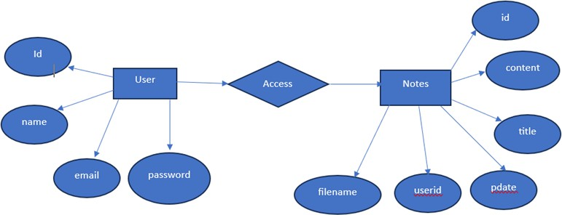

Fig. 3.1 Database Design

**Firebase Database: An In-Depth Exploration**

Firebase Database is a real-time, NoSQL cloud-hosted database that allows developers to store and sync data between users and devices in real-time. It is a core component of Google’s Firebase platform, which provides a suite of tools to build and manage mobile and web applications. Firebase Database comes in two flavors: the Realtime Database and Firestore. Each offers unique features and capabilities, catering to different needs and use cases.

**1. Firebase Realtime Database**

**Overview:** The Firebase Realtime Database is a cloud-hosted database. Data is stored as JSON and synchronized in real-time to every connected client. This makes it particularly suitable for applications that require frequent and immediate updates across multiple users, such as chat applications, collaborative tools, and live feed applications.

**Key Features:**

* **Real-Time Synchronization:** Data changes on any client device are instantly reflected across all connected devices. This ensures that all users have the most up-to-date information.
* **Offline Capabilities:** The Realtime Database supports offline use. When the device regains connectivity, it synchronizes local changes with the remote database, ensuring seamless user experience.
* **Scalability:** Designed to handle massive amounts of data and a high number of concurrent connections, making it suitable for applications of all sizes.
* **Security:** Firebase provides robust security features through Firebase Authentication and Realtime Database Security Rules, allowing developers to control access to data at a granular level.
* **Integration with Firebase Services:** The Realtime Database integrates smoothly with other Firebase services like Analytics, Cloud Functions, and Cloud Messaging, enabling a powerful and cohesive development experience.

**Use Cases:**

* **Chat Applications:** Real-time synchronization ensures that messages are instantly delivered to all users.
* **Collaborative Tools:** Applications like document editors or project management tools benefit from real-time updates.
* **Live Feeds:** News, sports updates, and social media feeds require immediate data updates to enhance user engagement.

**2. Firestore (Cloud Firestore)**

**Overview:** Firestore is Firebase's newer database offering, designed to overcome some of the limitations of the Realtime Database. It offers more powerful querying, better scalability, and a more flexible data model. Firestore is structured to handle complex data hierarchies and provides advanced querying capabilities.

**Key Features:**

* **Hierarchical Data Structure:** Firestore uses collections and documents to organize data hierarchically, allowing for more structured and readable data models compared to the flat JSON structure of the Realtime Database.
* **Advanced Querying:** Firestore supports complex queries that can filter and sort data in various ways. This includes compound queries, range queries, and support for indexing.
* **Real-Time Updates:** Like the Realtime Database, Firestore provides real-time data synchronization across devices.
* **Offline Support:** Firestore caches data locally, allowing for offline access and seamless synchronization when connectivity is restored.
* **Scalability and Performance:** Firestore is designed to scale automatically with your app's user base and provides strong consistency guarantees.
* **Security and Access Control:** Firestore uses Firebase Authentication and Firestore Security Rules to enforce data access controls.

**Use Cases:**

* **E-commerce Applications:** Firestore’s querying capabilities make it ideal for inventory management, product listings, and order tracking.
* **Social Networks:** Complex data structures and real-time updates support features like user profiles, posts, and interactions.
* **Content Management Systems (CMS):** The hierarchical data model and real-time synchronization are perfect for managing content dynamically.

**Comparison: Realtime Database vs. Firestore**

* **Data Model:**
  + **Realtime Database:** JSON tree structure.
  + **Firestore:** Collection-document model.
* **Query Capabilities:**
  + **Realtime Database:** Limited query capabilities; can only sort or filter on a single property.
  + **Firestore:** Advanced querying with compound queries, range queries, and indexing support.
* **Scalability:**
  + **Realtime Database:** Can handle high traffic but may require sharding and partitioning for very large datasets.
  + **Firestore:** Designed for scalability with automatic scaling and efficient handling of large datasets.
* **Consistency:**
  + **Realtime Database:** Eventual consistency.
  + **Firestore:** Strong consistency within a document; eventual consistency across documents.
* **Offline Support:**
  + Both databases provide robust offline capabilities, but Firestore’s implementation is more sophisticated with better support for complex data structures.

**Integration with Other Firebase Services**

Firebase Database, whether using Realtime Database or Firestore, integrates seamlessly with other Firebase services:

* **Firebase Authentication:** Simplifies user authentication and secures data access.
* **Firebase Cloud Functions:** Extends database functionality with serverless backend logic.
* **Firebase Analytics:** Tracks user engagement and database usage.
* **Firebase Cloud Messaging:** Enables real-time notifications based on database changes.
* **Firebase Storage:** Handles file storage needs alongside database operations.

**Security and Access Control**

Both Firebase Realtime Database and Firestore employ a powerful security rules engine:

* **Security Rules:** Define who has access to what data and under what conditions.
* **Firebase Authentication:** Provides a straightforward way to authenticate users and integrate with the database security rules.

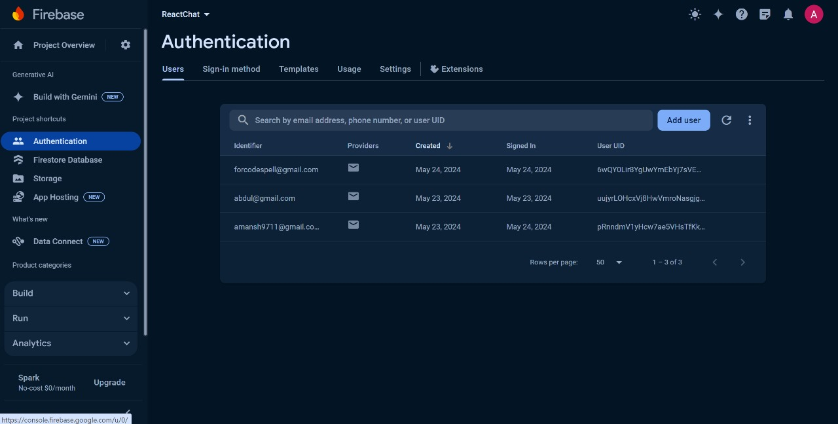

* 1. **Database Tables**

Database tables include User, Message, and Room tables. User table stores user information, Message table stores chat messages, and Room table manages chat room data and relationships.. Here's a basic representation:

* + 1. **Users Table:**
* **user_id (Primary Key):** Unique identifier for each user.
* **email:** User’s email address for communicate and login.
* **name:** User’s full name.
* **password:** Securely hashed password for authentication.

Fig 3.1.1 User

* + 1. **Chat Table:**
* **Chat_Id:** Unique id given to every chat.
* **Last-Message:**  Last chat.
* **Receiver_Id:** unique id for receiver end
* **updatedAt:** Chat Details

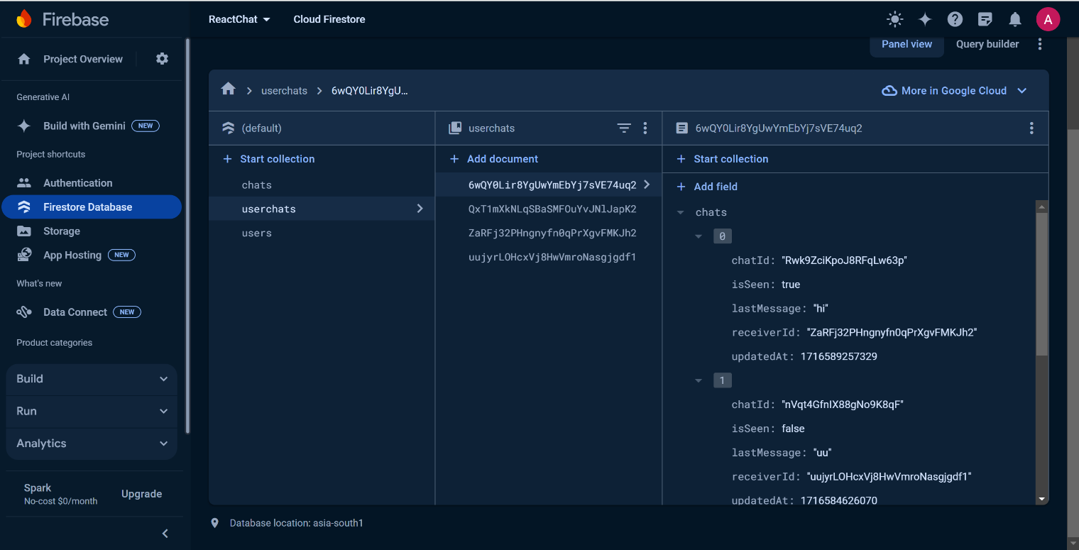

Table 3.2. Chat Table

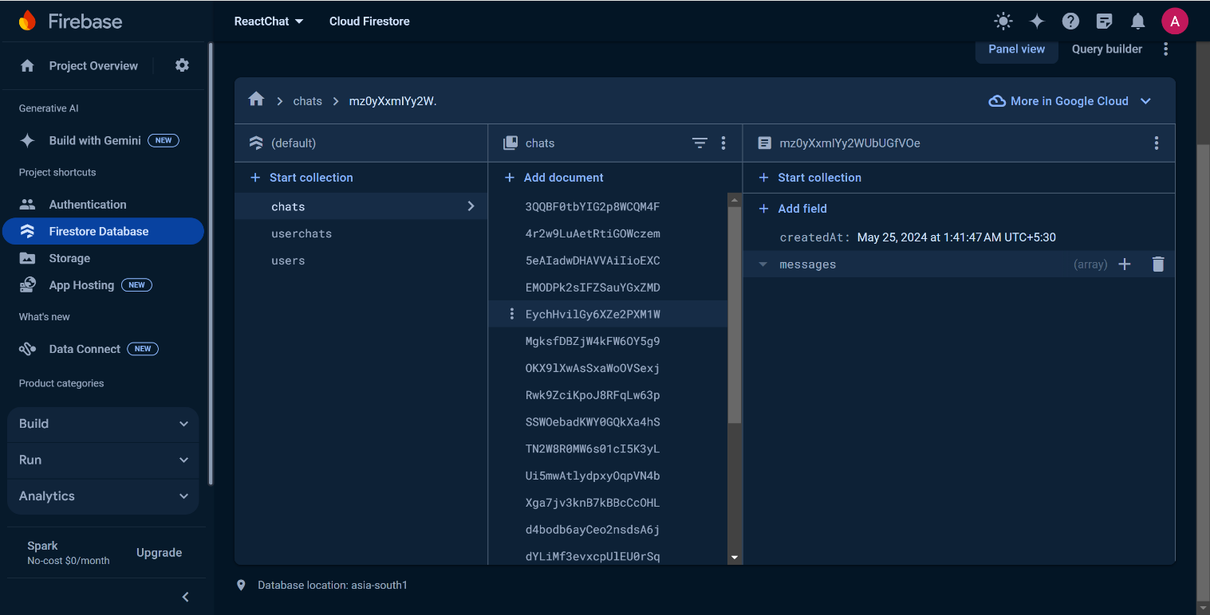

Fig 3.4 Message

* 1. **Flowchart**

**Introduction to the Flowchart for Real Time Chat App :**

A flowchart for a real-time chat application visually outlines the sequential steps and interactions within the system, facilitating a clear understanding of the process flow. It starts with user authentication, where users log in or register. Once authenticated, the flow moves to the main chat interface, enabling users to send and receive messages. The server handles message transmission, ensuring real-time updates across all connected clients. Additional features, such as creating and managing notes, uploading files, and notifications, are integrated into the flow. Each component, from the user interface to the server and database interactions, is represented, highlighting data flow and decision points. This visual representation aids developers and stakeholders in grasping the app's architecture, ensuring seamless communication, and pinpointing potential areas for optimization and enhancement.

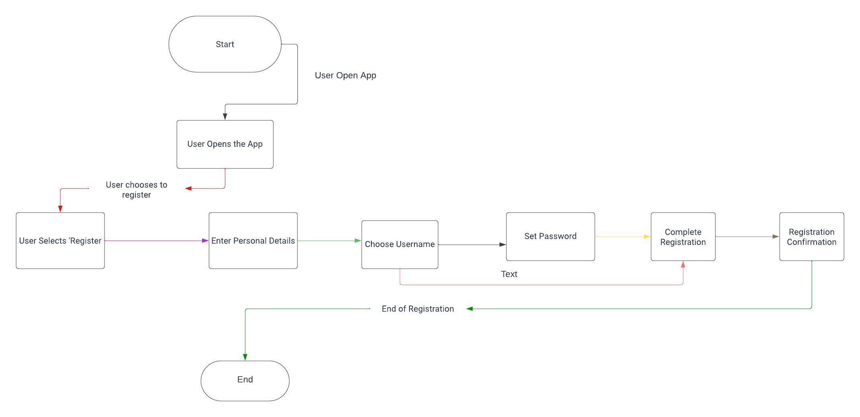

Fig. 3.5 Flowchart Diagram for Real Time Chat App

* 1. **Use Case Diagram**

A Use Case Diagram for a real-time chat application serves as a critical visual tool that delineates the system's functional requirements and the interactions between users and the application. This diagram helps in mapping out how various users (actors) engage with different functionalities (use cases) within the application, providing a high-level overview of the system's behavior.

In a real-time chat application, the primary actors include regular users, administrators, and possibly external services like third-party authentication providers (e.g., Google, Facebook). Each actor has specific interactions with the system that are depicted as use cases.

Key use cases for regular users include user authentication (registration, login, logout), sending and receiving messages, managing group chats, sharing files, creating and managing notes, receiving notifications, managing user profiles, and searching chat history. For administrators, use cases extend to user account management, permission control, and content moderation to maintain the application's integrity and security.

The Use Case Diagram clarifies these interactions, showing which actor is responsible for each use case. Lines connect actors to their respective use cases, illustrating the relationships and dependencies. This diagram is essential for developers and stakeholders as it provides a comprehensive view of the application's functionalities and helps ensure that all user requirements are captured and addressed during the development process. It aids in planning, communicating requirements, and validating the system's design.

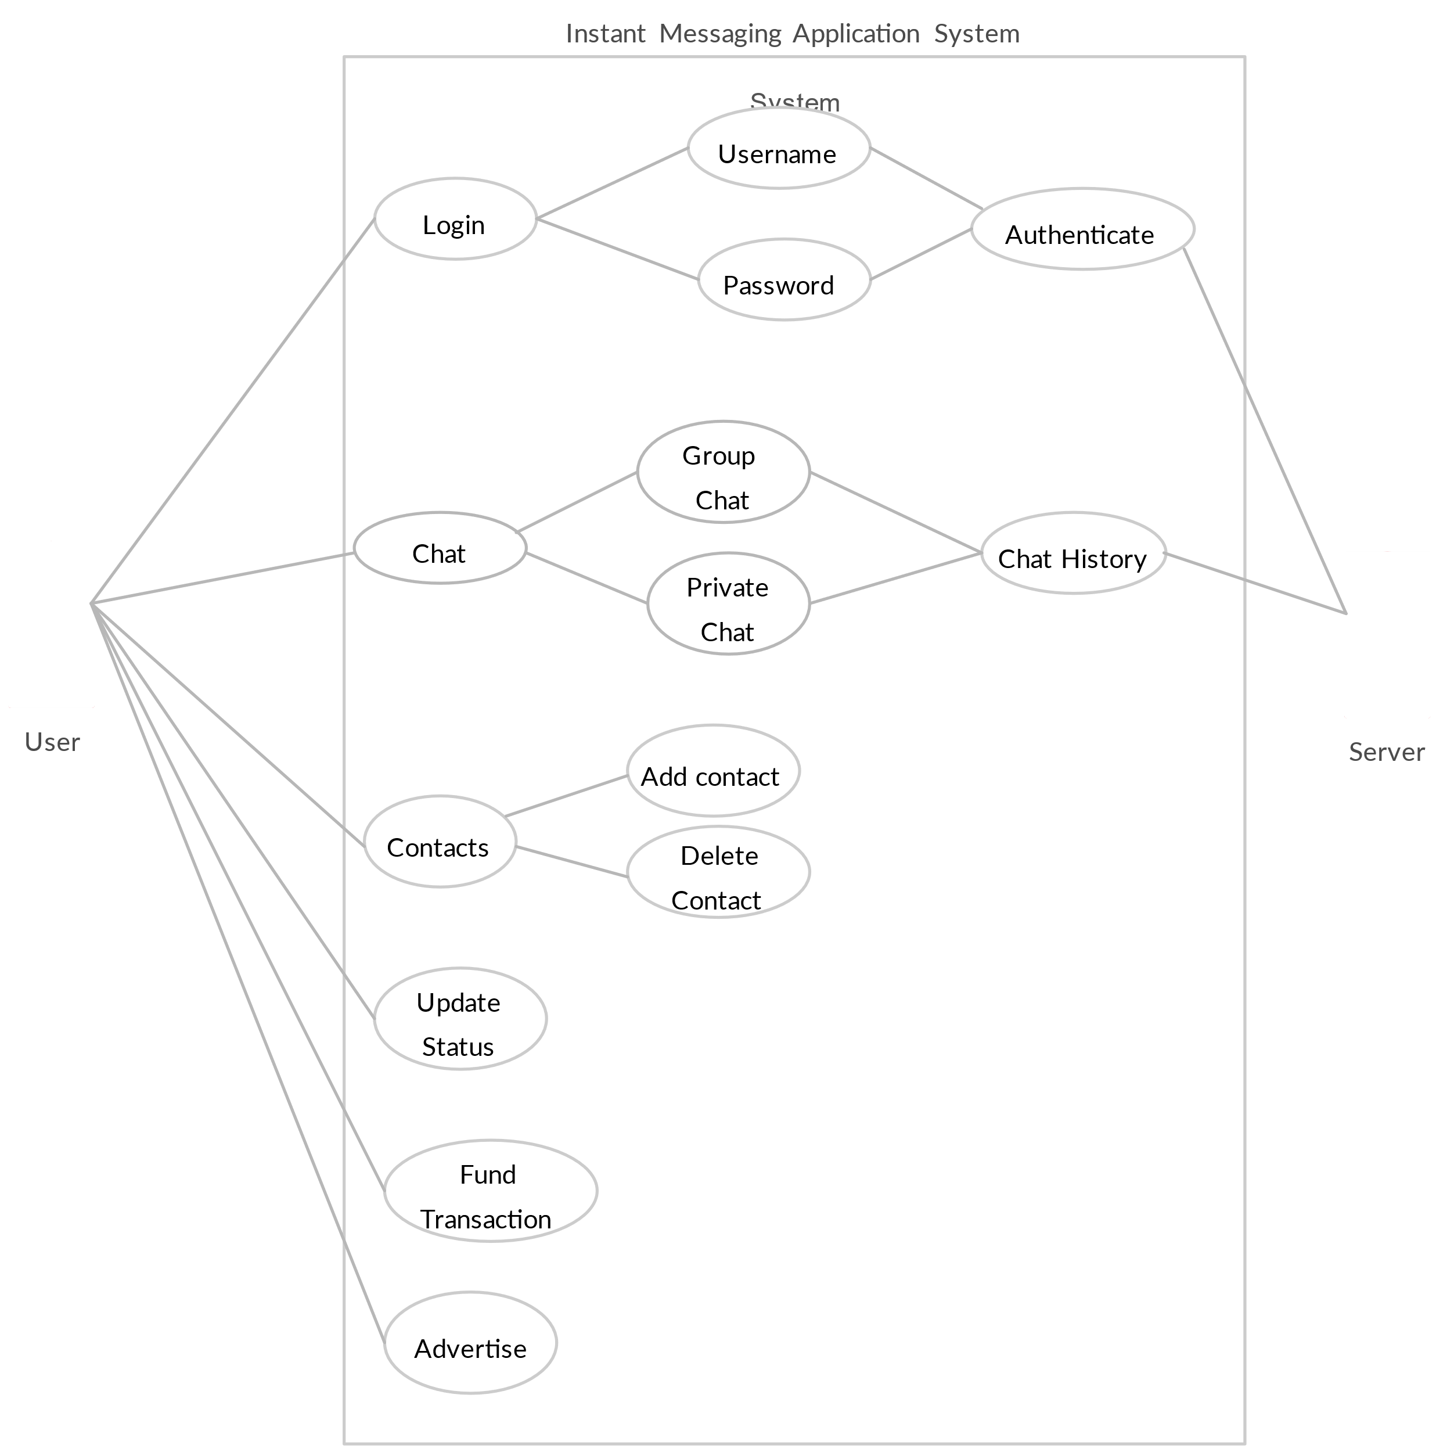

Fig. 3.6 Use Case Diagram for Chat App

* + 1. **Actors:**
* User
* System
  + 1. **Use Case**
* Register
* Login
* Sign Up
* Open Dashboard
* Create Chat
* View Chats

In the Real-Time Chat App, when the user opens the web page, they encounter two modes: registration or login. If they are a new user, they must register themselves; otherwise, they simply log in with valid credentials such as email ID and password created during registration. Upon filling in their credentials, the system checks them against the database to verify their authenticity. If the credentials are correct, the user is directed to the chat dashboard; otherwise, an error message is displayed.

Once on the dashboard, users have multiple choices. They can start new conversations or join existing ones, send and receive messages in real-time, and manage their contacts. Users can create group chats, invite participants, and manage group settings. They also have the option to share files and media within the chat, enhancing communication with multimedia elements. Notifications are provided for new messages and activities, ensuring users stay informed.

Users can search for specific conversations or messages using the search feature. The app includes security measures to protect data and ensure privacy. Users can also personalize their profile settings, including updating their display name and profile picture.

After completing their activities, users can log out of the application. Their chat history and settings are saved in the database, allowing them to resume conversations seamlessly in future sessions by simply logging back in. The real-time nature of the app ensures that users experience immediate message delivery and updates, fostering efficient and effective communication.

* 1. **Data Flow Diagram**

The Data Flow Diagram (DFD) for the Real-Time Chat App provides a visual representation of the flow of data within the system, illustrating how information moves between various components. At its core, the DFD encapsulates the key processes, data stores, and data flows involved in the chat application. Starting with user inputs, such as registering, logging in, and sending messages, the diagram delineates how these interactions trigger processes like data validation, message transmission, and database updates.

The DFD begins with user actions like registration and login, where credentials are validated against the database. Successful authentication directs users to the main chat interface, where they can send and receive messages in real time. This process involves the server, which handles message broadcasting to other users or groups, ensuring instant delivery.

The diagram also portrays the storage and retrieval of user data, chat history, and media files in the database, emphasizing the seamless exchange of information between users and the application. It includes processes for file uploads, where the system verifies and stores files, making them available for sharing within chats.

Notifications are another critical component, depicted in the DFD, showcasing how the system sends real-time alerts for new messages and other events. The search functionality allows users to query the database for specific conversations or messages, facilitating quick access to relevant information.

By encapsulating the fundamental data movements and transformations, the DFD serves as a valuable blueprint for understanding the Real-Time Chat App's operational dynamics. It provides a clear overview of how user interactions translate into backend processes and data exchanges, ensuring efficient and effective communication within the application.

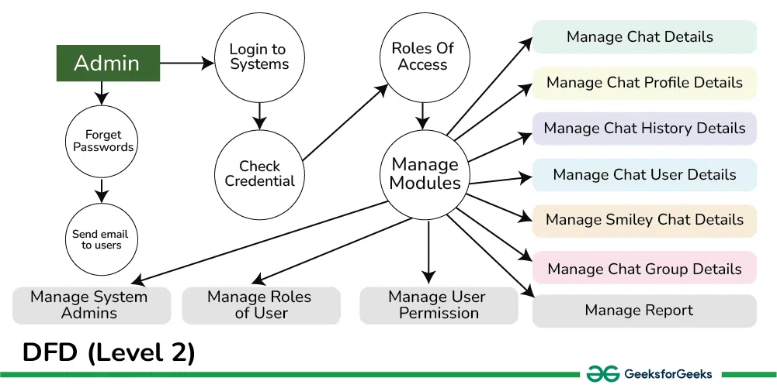

Fig. 3.7 Data Flow Diagram for Real Time Chat App

**CHAPTER 4**

**TECHNOLOGY**

**Firebase Database: Expanding the Horizons**

Firebase Database, including both Firebase Realtime Database and Firestore, provides developers with a comprehensive platform for building robust, scalable, and responsive applications. These databases support a wide range of functionalities and integrate seamlessly with other Firebase services, making them versatile tools for developers. Let's delve deeper into various aspects of Firebase Database to provide a more nuanced understanding of its capabilities and use cases.

**Data Management and Modeling**

**1. Realtime Database:**

The Firebase Realtime Database uses a simple JSON tree structure. This flat, hierarchical data model is easy to set up and understand but can become unwieldy as the data complexity increases.

* **Data Structuring:** In Realtime Database, all data is stored as JSON objects. Each node in the tree can hold either simple values (strings, numbers) or other nested nodes. This structure is intuitive for small datasets.
* **Data Retrieval:** To retrieve data, developers use references to specific locations in the tree. The database supports basic queries like sorting and filtering based on a single property, but more complex queries can be challenging to implement efficiently.

**2. Firestore:**

Firestore uses a more structured data model based on collections and documents, allowing for more organized and flexible data storage.

* **Collections and Documents:** Data in Firestore is stored in documents, which are organized into collections. Documents can contain subcollections, allowing for nested data structures that can model more complex relationships.
* **Data Retrieval:** Firestore provides advanced querying capabilities, including compound queries, array-contains queries, and range queries. These features allow developers to retrieve data more efficiently and flexibly.
* **Data Consistency:** Firestore offers strong consistency guarantees within documents and eventual consistency across collections. This ensures reliable data integrity and availability.

**Performance and Scalability**

**Realtime Database:**

* **Scalability:** The Realtime Database can handle a high number of concurrent connections, making it suitable for applications with heavy real-time data requirements. However, as the size and complexity of the data grow, performance may degrade due to the flat JSON structure.
* **Sharding and Partitioning:** To manage large datasets, developers might need to implement sharding and partitioning manually. This involves dividing the data into smaller chunks and distributing them across multiple database instances.

**Firestore:**

* **Automatic Scaling:** Firestore is designed to scale automatically with your application's needs. It can handle large datasets and high traffic loads without requiring manual sharding.
* **Optimized Performance:** Firestore’s architecture supports efficient querying and data retrieval. It uses indexes to speed up queries, ensuring quick response times even with large datasets.

**Security and Authentication**

**Firebase Authentication:**

* Firebase Authentication provides a simple and secure way to manage user authentication. It supports various authentication methods, including email and password, phone authentication, and federated identity providers like Google, Facebook, and Twitter.
* Integration with the Realtime Database and Firestore allows for seamless user management and data security. Authentication states can be used to control data access and enforce security rules.

**Security Rules:**

* **Realtime Database Security Rules:** These rules are written in JSON and define how data should be structured and accessed. They can be used to enforce data validation, control read/write permissions, and restrict access based on user authentication status.
* **Firestore Security Rules:** Firestore uses a similar but more expressive language for security rules. These rules allow for complex access controls, including conditions based on document fields, user roles, and other factors.

**Integration with Other Firebase Services**

Firebase Database integrates seamlessly with a variety of Firebase services, enhancing its functionality and providing a more holistic development experience:

**1. Firebase Cloud Functions:**

* Cloud Functions allow developers to run backend code in response to events triggered by Firebase features. For example, developers can write functions to automatically send notifications, update other databases, or process data when a document in Firestore is created or modified.

**2. Firebase Analytics:**

* Firebase Analytics provides detailed insights into user behavior and app performance. It can track user interactions with the database, helping developers understand how users are engaging with their app and where improvements can be made.

**3. Firebase Cloud Messaging:**

* Cloud Messaging enables developers to send notifications and messages to users based on database changes. For example, a messaging app can use Cloud Messaging to notify users of new messages in real-time.

**4. Firebase Storage:**

* Firebase Storage is used to store and serve user-generated content such as photos and videos. It integrates with both Realtime Database and Firestore, allowing developers to link storage files with database records seamlessly.

**Practical Considerations and Best Practices**

**Data Structuring:**

* **Normalization:** Avoid deeply nested structures in Realtime Database to prevent performance issues. Instead, normalize data by breaking it into smaller, manageable pieces.
* **Hierarchical Data:** Use Firestore’s collection-document model to maintain a clear and logical data hierarchy, which simplifies data retrieval and management.

**Performance Optimization:**

* **Indexing:** Leverage Firestore’s indexing capabilities to optimize query performance. Ensure that frequently queried fields are properly indexed.
* **Data Caching:** Utilize Firestore’s built-in offline caching to enhance app responsiveness and reduce load times.

**Security:**

* **Granular Access Control:** Define detailed security rules to protect sensitive data. Use Firebase Authentication to ensure that only authorized users can access specific data.
* **Data Validation:** Implement data validation rules to maintain data integrity and prevent malformed data from being written to the database.

**Scalability:**

* **Load Testing:** Regularly perform load testing to identify potential bottlenecks and optimize database performance.
* **Automatic Scaling:** Rely on Firestore’s automatic scaling capabilities to handle increased traffic and data load seamlessly.

**React: A Comprehensive Guide**

React is a JavaScript library developed by Facebook, primarily used for building user interfaces, especially single-page applications where responsiveness and dynamic interactions are crucial. Since its release in 2013, React has revolutionized web development by introducing concepts that enhance performance, simplify development, and improve code maintainability. This comprehensive guide delves into the core principles, features, advantages, ecosystem, and best practices associated with React.

**Core Principles**

1. Component-Based Architecture:

React embraces a component-based architecture**,** which allows developers to break down complex user interfaces into smaller, reusable components. Each component encapsulates its logic, rendering, and styles, making the application easier to manage and scale.

* Components: These are the building blocks of a React application. They can be class-based or functional, with the latter being more prevalent due to the advent of hooks.
* Props: Short for properties, props are used to pass data from parent components to child components.
* State: State is used to manage data that changes over time within a component. State changes trigger re-rendering, updating the UI to reflect the new state**.**

**2. Virtual DOM:**

One of React’s most significant innovations is the Virtual DOM, a lightweight copy of the actual DOM. React maintains a Virtual DOM to optimize updates and rendering.

* Efficient Updates: When the state or props of a component change, React updates the Virtual DOM first. It then calculates the minimum number of changes needed to update the actual DOM, leading to improved performance.
* Reconciliation: This is the process where React determines what changes need to be made to the actual DOM based on the differences between the current and previous versions of the Virtual DOM.

**3. Declarative UI:**

React’s declarative approach simplifies the process of building UIs. Developers describe what the UI should look like for different states of the application, and React takes care of updating the UI when the state changes.

* JSX: JavaScript XML (JSX) is a syntax extension that allows developers to write HTML-like code within JavaScript. It is transpiled to JavaScript and enhances the readability and maintainability of the code.
* One-Way Data Binding: React employs unidirectional data flow, meaning data moves in a single direction, typically from parent to child components. This simplifies debugging and understanding data flow in the application.

**Key Features**

**1. Hooks:**

Introduced in React 16.8, hooks are functions that allow developers to use state and other React features in functional components. They have transformed how React applications are developed by simplifying state management and side effects.

* useState: Allows functional components to have local state.
* useEffect: Manages side effects like data fetching, subscriptions, and manual DOM manipulations.
* Custom Hooks: Developers can create custom hooks to encapsulate and reuse logic across multiple components.

2. Context API:

The Context API provides a way to pass data through the component tree without having to pass props down manually at every level. This is particularly useful for global data like themes, user authentication, and settings.

* Context Provider: Wraps the component tree and supplies the context value.
* Concurrent Context Consumer: Consumes the context value within a component.

3. Concurrent Mode:

Mode is an experimental set of features designed to make React applications more responsive by rendering updates concurrently. It improves the user experience by making the application feel faster and more fluid.

* Suspense: Allows components to wait for something (like data fetching) before rendering.
* Time Slicing: Breaks down rendering work into chunks, allowing React to work on other tasks while waiting for slower operations to complete.

4. Server-Side Rendering (SSR):

Server-Side Rendering renders React components on the server and sends HTML to the client. This improves the initial load time and SEO, as search engines can crawl the content more effectively.

* Next.js: A popular React framework that simplifies SSR and offers features like static site generation, API routes, and more.

Advantages of React

1. Performance:

React’s use of the Virtual DOM and efficient reconciliation process ensures high performance, even for complex and data-intensive applications. This results in smoother user experiences and faster load times.

2. Reusability:

The component-based architecture promotes reusability, reducing development time and effort. Components can be reused across different parts of an application or even across different projects.

3. Maintainability:

React’s declarative approach and unidirectional data flow make code more predictable and easier to debug. The use of components and hooks encourages writing modular and maintainable code.

4. Ecosystem:

React has a vast and active ecosystem, with numerous libraries and tools that complement its capabilities. Popular tools include:

* React Router: For handling routing in React applications.
* Redux: A state management library for managing complex application state.
* Styled-components: For writing CSS-in-JS, allowing for scoped and themeable styles.
* Formik: For managing forms in React applications.

React Ecosystem

1. State Management:

While React’s built-in state management is suitable for local component state, larger applications often require more robust solutions.

* Redux: A predictable state container that helps manage application state in a centralized store. It follows principles of a single source of truth, making state changes more predictable.
* MobX: An alternative state management library that uses observables to track state changes and automatically update the UI.
* Recoil: Developed by Facebook, Recoil provides a simpler way to manage global state with a focus on performance and ease of use.

2. Routing:

React Router is the de facto standard for adding navigation and routing in React applications. It allows developers to define routes and manage the history of the application efficiently.

* Dynamic Routing: React Router supports dynamic routing, enabling routes to be defined as part of the application rendering.
* Nested Routes: Allows for nested UI structures with nested routes.

3. Styling:

React offers various approaches to styling components, from traditional CSS to modern CSS-in-JS solutions.

* CSS Modules: Scoped CSS by default, reducing the risk of style conflicts.
* Styled-components: A popular CSS-in-JS library that allows developers to write actual CSS code to style components.
* Emotion: Another powerful CSS-in-JS library that provides flexible styling solutions.

4. Testing:

Testing is a crucial aspect of React application development, ensuring code reliability and preventing regressions.

* Jest: A JavaScript testing framework maintained by Facebook, commonly used for testing React applications.
* React Testing Library: Focuses on testing React components from the user’s perspective, promoting best practices in testing.
* Enzyme: Developed by Airbnb, Enzyme provides utilities for testing React components but is less favored than React Testing Library for modern React testing practices.

1. Component Design:

* Single Responsibility Principle: Each component should have a single responsibility, making it easier to understand, test, and maintain.
* Presentational vs. Container Components: Separate presentational components (UI) from container components (logic and state management).

2. State Management:

* Local vs. Global State: Use React’s useState and useReducer for local state management. For global state, consider Context API, Redux, or other state management solutions.
* Immutable State: Always treat state as immutable. Use techniques like the spread operator or libraries like Immer to update state immutably.

3. Performance Optimization:

* Memoization: Use React.memo, useMemo, and useCallback to memoize expensive calculations and prevent unnecessary re-renders.
* Code Splitting: Use dynamic import() and React.lazy to split code into smaller chunks, reducing the initial load time.
* Avoid Inline Functions: Define functions outside the render method or use useCallback to avoid re-creating functions on every render.

4. Accessibility:

* ARIA Roles: Use ARIA roles to make components accessible to screen readers.
* Semantic HTML: Use semantic HTML elements where appropriate, ensuring better accessibility and SEO.
* Focus Management: Ensure proper focus management, especially for modal dialogs and interactive components.

**Toastify:**

**Overview**

Toastify is a popular JavaScript library for creating customizable, non-blocking toast notifications for web applications. It is highly favored for its ease of use, flexibility, and ability to enhance user experience by providing timely and unobtrusive feedback. This comprehensive note explores Toastify's features, usage, customization options, integration with frameworks, and best practices.

Introduction to Toastify

Toasts are small, temporary, and often animated notifications that appear on the screen to inform users of certain events or actions without interrupting their current activity. Toastify.js, commonly referred to as Toastify, is a lightweight and versatile library that simplifies the implementation of such notifications in web applications.

Core Features

1. Ease of Use:

* Simple API: Toastify provides a straightforward API that allows developers to create toast notifications with minimal code. The basic setup requires only a few lines of JavaScript.
* Quick Setup: Including Toastify in a project is easy, with options to use CDN links or install it via npm/yarn.

2. Customization:

* Appearance: Customize the look and feel of toast notifications, including background color, text color, font, and icons.
* Positioning: Toasts can be positioned anywhere on the screen, such as top-right, top-left, bottom-right, or bottom-left.
* Duration: Control how long the toast remains visible before automatically dismissing. Options for infinite duration are also available.

3. Behavior:

* Auto-Close: Toasts can auto-close after a specified duration, or they can require user interaction to dismiss.
* Interactive: Include clickable buttons, links, or other interactive elements within the toast.
* Animations: Customize the entry and exit animations of toasts to improve visual appeal.

4. Accessibility:

* Screen Reader Support: Toastify toasts are designed to be accessible and can be read by screen readers, enhancing the user experience for visually impaired users.
* ARIA Attributes: Proper ARIA attributes ensure that toasts are announced correctly to users relying on assistive technologies.

Best Practices

1. Consistent Styling:

* Theming: Use consistent styling across all toasts to maintain a cohesive look and feel. Define common styles in your CSS and apply them to Toastify notifications.
* Responsive Design: Ensure that toasts are responsive and look good on all screen sizes. Use relative units like percentages or viewport units for positioning and sizing.

2. Accessibility:

* Announcements: Ensure that toast notifications are announced by screen readers. Use ARIA roles and attributes to make toasts accessible.
* Keyboard Navigation: Allow toasts to be dismissible using keyboard interactions. Ensure that interactive elements within toasts are focusable.

3. Performance Optimization:

* Minimal Duration: Avoid keeping toasts on screen for too long. Use appropriate durations to prevent clutter and ensure that users are not overwhelmed by notifications.
* Efficient Resource Use: Clean up resources and remove toasts from the DOM once they are dismissed to prevent memory leaks and ensure optimal performance.

4. User Interaction:

* Actionable Toasters: Provide actionable toasts for events that require user feedback or action. Include buttons or links that allow users to respond immediately.
* Dismissibility: Ensure that toasts can be dismissed by users, either through a close button or by clicking on the toast itself.

5. Contextual Relevance:

* Contextual Messaging: Display toasts that are contextually relevant to the user’s current activity. Avoid showing irrelevant or redundant notifications.
* Priority Handling: Handle the priority of toasts appropriately. Display critical notifications prominently, while less important messages can be less obtrusive.

Zustand: A Comprehensive Overview

Zustand is a small, fast, and scalable state management library for React applications. The name "Zustand" comes from the German word for "state," reflecting its primary function. Zustand offers a minimalistic and flexible approach to state management, enabling developers to manage application state efficiently without the boilerplate and complexity associated with other state management solutions like Redux. This comprehensive note explores the core features, usage, best practices, and integration of Zustand within React applications.

Introduction to Zustand

Zustand is designed to provide a more intuitive and lightweight alternative to state management in React applications. It is built with simplicity and performance in mind, offering a straightforward API and excellent performance characteristics. Zustand is particularly well-suited for applications that require a global state but do not want the overhead of more complex libraries.

Core Features

1. Simple and Intuitive API:

* Minimal Boilerplate: Zustand requires minimal boilerplate code compared to other state management solutions. Its API is easy to understand and use, making it accessible to developers of all skill levels.
* Hooks-based API: Zustand leverages React hooks for managing state, aligning with modern React development practices.

2. Performance:

* Fast State Updates: Zustand is optimized for performance, ensuring fast state updates and rendering.
* No Selector Hell: Zustand avoids the common performance pitfalls associated with selectors in other state management libraries.

3. Flexible State Management:

* Global and Local State: Zustand can manage both global and local state effortlessly. This flexibility allows developers to use it for a variety of state management needs.
* Reactive State: Zustand's state management is reactive, meaning components automatically re-render when the state they depend on changes.

4. Middleware Support:

* Extendable: Zustand supports middleware, allowing developers to extend its functionality. Middleware can be used for logging, handling asynchronous actions, and more.

Best Practices

1. Structuring State:

* Modular State: Break down your state into logical modules to keep the state management organized and maintainable.
* Encapsulation: Encapsulate state logic within the Zustand store to avoid leaking implementation details.

2. Performance Optimization:

* Selective State Usage: Use only the necessary parts of the state in your components to avoid unnecessary re-renders.
* Memoization: Leverage React's useMemo and useCallback hooks to memoize expensive calculations and functions.

3. Asynchronous Actions:

* Async/Await: Use async/await for handling asynchronous actions within your Zustand store for better readability and error handling.
* Error Handling: Implement proper error handling in your asynchronous actions to handle failures gracefully.

4. Testing:

* Unit Testing: Write unit tests for your Zustand stores to ensure that state updates behave as expected.
* Integration Testing: Test the integration of Zustand with your React components to verify that the state management is functioning correctly in the context of your application.

5. Middleware:

* Custom Middleware: Create custom middleware for cross-cutting concerns like logging, analytics, and error reporting.
* Chaining Middleware: Middleware in Zustand can be chained to create complex behaviors. Ensure that middleware is composed correctly to avoid unexpected interactions.

**CHAPTER 5**

**FORM DESIGN**

**Introduction**

Designing effective forms for the Khelo Mate website is a comprehensive process that integrates usability, accessibility, visual appeal, and functionality to create a seamless user experience. This extensive guide will delve into various principles and best practices that ensure the forms on the Khelo Mate website are user-friendly, visually appealing, and functionally efficient.

**User-Friendly Layout**

The foundation of a well-designed form starts with a user-friendly layout. The form should be organized in a way that aligns with the user’s expectations and the natural flow of information. This involves several key considerations**:**

**Logical Flow**

Forms should have a logical flow that guides the user through the process in an intuitive manner. The sequence of fields should make sense and reflect the natural order in which information is typically entered. For instance, starting with basic personal information like name and email before moving on to more detailed sections ensures a smooth experience**.**

**Grouping Related Fields**

Grouping related fields together can significantly improve the user experience. For example, all contact information fields (such as address, phone number, and email) should be grouped in one section. This helps users understand the form’s structure and reduces cognitive load by organizing information into manageable chunks.

**Field Labels and Placeholders**

Clear and concise labels for each field are crucial. Labels should be descriptive enough to convey the required information without being overly verbose. Placeholders can provide additional guidance by giving examples of what is expected in each field. However, placeholders should not replace labels, as they disappear when the user starts typing, which can lead to confusion.

**Visual Design**

The visual design of a form is another critical aspect that affects usability and user engagement. A well-designed form should be visually appealing without sacrificing functionality.

**Clean and Simple Design**

A clean and simple design is key to creating a user-friendly form. Avoid cluttering the form with unnecessary elements that can distract users. Each element on the form should have a clear purpose and contribute to the overall goal of collecting information efficiently.

**Consistent Styling**

Consistency in styling is important for creating a cohesive user experience. This includes using the same font type, size, color, and spacing throughout the form. Consistent styling helps users quickly understand the form’s structure and reduces the time it takes to complete it.

**Form Fields**

The design and implementation of form fields play a crucial role in the overall user experience. Properly designed fields can make data entry straightforward and error-free.

**Input Types**

Using appropriate input types for different fields improves data accuracy and user experience. For example, using the "email" input type for email fields ensures that the keyboard on mobile devices is optimized for email entry, and it can trigger validation checks that help ensure the entered data is correctly formatted**.**

**Field Validation**

Implementing real-time validation provides immediate feedback to users as they fill out the form. This can help prevent errors and improve the overall experience. Error messages should be clear and specific, indicating exactly what needs to be corrected. For instance, instead of a generic "Invalid input" message, specify "Please enter a valid email address."

**Accessibility**

Ensuring that forms are accessible to all users, including those with disabilities, is essential. Accessible design not only broadens the user base but also complies with legal requirements.

**Keyboard Navigation**

Forms should be fully navigable using only a keyboard. This is crucial for users who rely on assistive technologies. Make sure that all interactive elements, such as input fields, buttons, and links, can be accessed and used via keyboard shortcuts.

**Labels and Instructions**

Providing accessible labels and instructions for each field is essential. Use ARIA (Accessible Rich Internet Applications) attributes where necessary to enhance accessibility. ARIA attributes help convey information about the form’s structure and behavior to assistive technologies, making it easier for users with disabilities to interact with the form.

**Mobile Responsiveness**

In today’s digital landscape, ensuring that forms are responsive and work well on various devices and screen sizes is crucial. A mobile-first approach can be particularly effective.

**Responsive Design**

Design forms to be fully responsive, ensuring they adapt to different screen sizes and orientations. This involves using flexible layouts, scalable images, and media queries to adjust the form’s appearance based on the device being used.

**Touch-Friendly Elements**

Ensure that form elements are touch-friendly, with sufficient spacing to prevent accidental selections on touchscreens. Buttons and links should be large enough to be easily tapped, and there should be adequate spacing between interactive elements to avoid unintentional inputs.

**Security**

Security is a paramount concern when designing forms, especially when collecting sensitive information. Users need to feel confident that their data is protected.

**Data Protection**

Use HTTPS to encrypt data transmission between the user’s browser and your server. This helps protect sensitive information from being intercepted by malicious actors. Additionally, implement measures to protect against common security threats like cross-site scripting (XSS) and SQL injection.

**Privacy Policy**

Clearly state your privacy policy regarding how user data will be used and protected. Include a link to the policy near the form, and ensure that users can easily access and understand it. Transparency about data usage builds trust and encourages users to complete the form.

**User Guidance**

Providing clear guidance to users throughout the form can improve completion rates and reduce errors.

**Tooltips and Help Text**

Tooltips or help text can provide additional information and clarification for fields that might be complex or require specific input. This can be done through icons or inline text that users can access if they need more information.

**Progress Indicators**

For multi-step forms, include progress indicators to show users where they are in the process and how many steps remain. This helps manage user expectations and reduces frustration by giving a clear sense of progress.

**Submission and Feedback**

The final steps of form submission and providing feedback to users are critical for ensuring a positive user experience.

**Clear Call to Action**

Use a prominent, clear call-to-action button for form submission. The button should stand out visually and be labeled with a specific action, such as "Register" or "Submit." This helps users understand what will happen when they click the button.

**Confirmation Messages**

Provide clear confirmation messages upon successful submission, informing users that their data has been received and outlining any next steps. This can help reduce uncertainty and provide a sense of closure.

**Input/Output Screenshot**

The signin page serves as the gateway for users to access the application's features securely. It typically consists of a form where users can input their credentials, namely their user ID or email and password. Additionally, a navigation button provides a convenient way

for users to navigate to the signup page if they do not have an account yet. Here's a detailed description of the login page:

### Login Form:

**User ID Field:** A text input field where users can enter their user ID or email address. This field may include features like auto-focus for easy entry and validation to ensure the input format is correct.

**Password Field:** A password input field where users can enter their password securely. The password field typically hides the characters entered by the user to protect their sensitive information.

**Remember Me Checkbox:** An optional checkbox that allows users to opt-in to have their login credentials remembered for future visits, enabling them to log in automatically without re-entering their details.

**Sign in Button:** A button that users click to submit their login credentials and authenticate. Upon clicking the login button, the entered credentials are sent to the server for verification.

**Error Messages:** Displayed near the relevant input fields to notify users of any errors encountered during the login process, such as incorrect credentials or server issues.

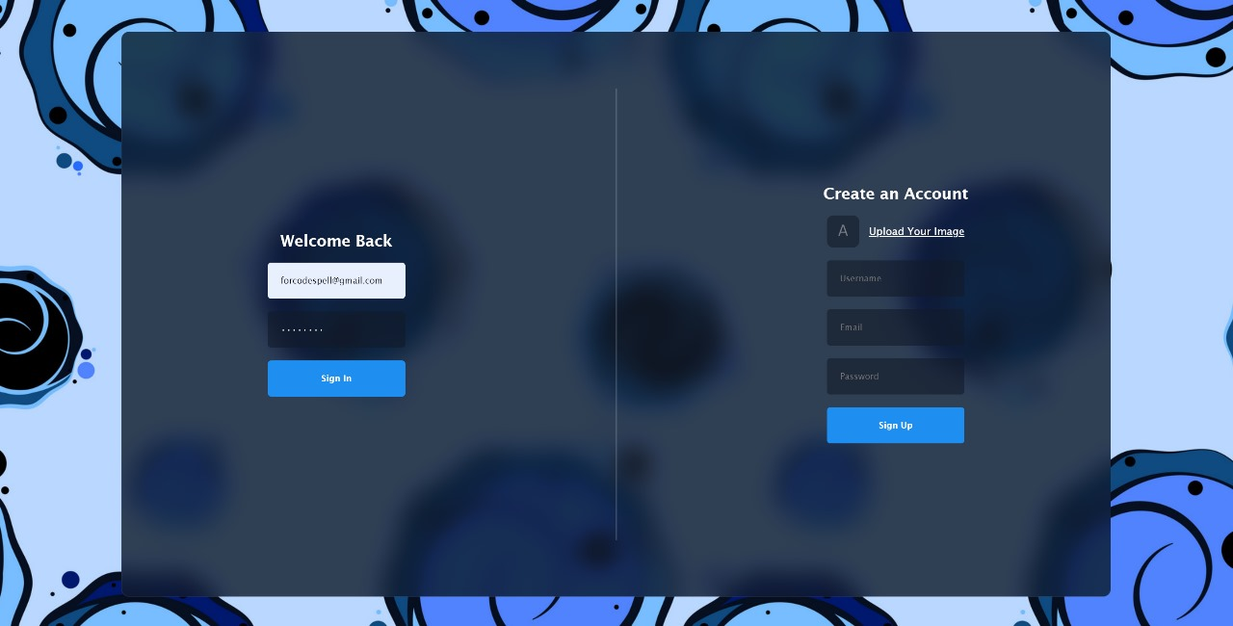

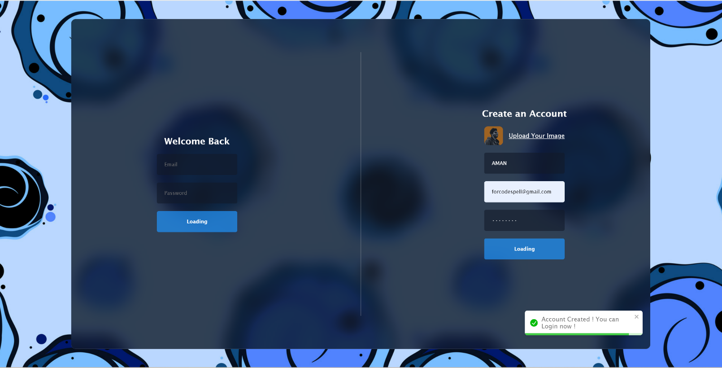

The registration page serves as the initial step for new users to create an account

within the application. It typically includes fields for users to input their desired user ID or email, password, and confirm password. Additionally, the registration process often involves. Here's a detailed description of the registration page:

**Upload Profile Photo:** A file input field where users can upload their profile photo. Otherwise it will automatically take an default avatar image.

**User ID Field:** A text input field where users can enter their desired user ID or email address. This field may include validation to ensure uniqueness and appropriate formatting.

**Email Field:** A text input field where users can enter their desired user ID or email address. This field may include validation to ensure uniqueness and appropriate formatting.

**Password Field**: A password input field where users can enter their desired password. Like the login page, this field hides the characters entered by the user for security purposes.

**Error Messages:** Displayed near the relevant input fields to notify users of any errors encountered during the registration process, such as invalid user IDs, mismatched passwords, or incorrect OTPs.

**Login Modules**

User can login with valid Credentials

If admin entered incorrect credentials, then alert will generate but if credentials are matched with the admin credentials, then admin can login.



**User Dashboard:**

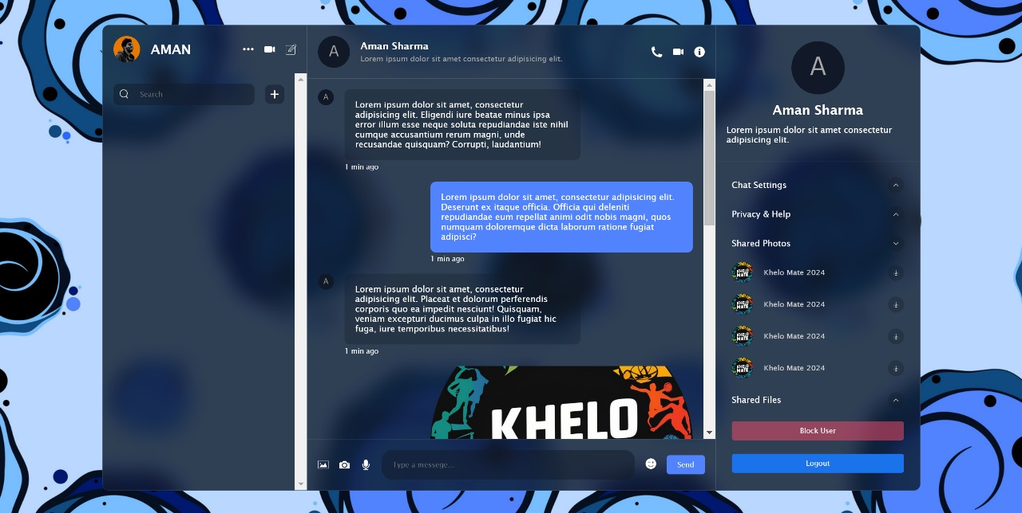

Designing a user dashboard for the Khelo Mate website involves creating a central hub where users can conveniently access key features and information relevant to their sports activities. The dashboard layout should prioritize ease of use, providing intuitive navigation and clear presentation of data. Personalization options should allow users to tailor their dashboard to their specific preferences and needs, enhancing their overall experience. Integrating interactive elements such as calendars, messaging systems, and notifications ensures that users stay informed and engaged with the platform. Emphasizing responsiveness and performance guarantees a seamless experience across devices, empowering users to manage their sports-related activities efficiently. Through thoughtful design and user-centric features, the Khelo Mate user dashboard aims to be a valuable companion for athletes, coaches, and sports enthusiasts alike.

**CHAPTER 6**

**TESTING**

**INTRODUCTION**

Testing is the bedrock of software development, especially in complex applications like the Real-Time Chat App. It serves as a vital phase in the development lifecycle, ensuring the application's functionality, performance, and reliability. This document delves into the multifaceted testing strategies employed to scrutinize the Real-Time Chat App thoroughly. By expanding on two pivotal test cases - User Registration and Sending Messages - this document aims to provide a comprehensive understanding of the rigorous testing methodologies employed in guaranteeing a seamless user experience.

**Understanding Testing Methodologies:**

The success of any testing endeavor hinges on a robust framework of methodologies. Unit testing dissects individual components to validate their functionality in isolation. Integration testing examines the cohesion between these components, ensuring they interact seamlessly. User acceptance testing validates the application's alignment with user expectations and specified requirements. In the context of the Real-Time Chat App, the amalgamation of these methodologies forms a comprehensive testing framework, essential for ensuring its reliability and effectiveness.

**Test Case-1: User Registration**

**Objective:** This test case aims to validate the user registration process within the Real-Time Chat App.

**Preconditions:**

* The Real-Time Chat App must be accessible and operational.
* The user must navigate to the registration page.

**Test Steps:**

1. Input valid information, including a unique email address, full name, and secure password, into the registration form.
2. Click on the "Submit" button to commence the registration process.

**Expected Results:**

* A confirmation message should be promptly displayed upon successful registration.
* The user's information, particularly their email, should be securely stored in the database for future authentication.

**Postconditions:**

* The user should seamlessly log in using the registered credentials, gaining access to the Real-Time Chat App's features and functionalities without hindrance.

**Test Case-2: Send Message**

**Objective:** This test case validates the core functionality of sending messages within the Real-Time Chat App.

**Preconditions:**

* The user must be logged into the Real-Time Chat App.

**Test Steps:**

1. Navigate to a designated chat window or conversation within the application.
2. Input a message into the provided text field.
3. Click on the "Send" button to dispatch the message.

**Expected Results:**

* The message should be promptly transmitted and seamlessly appear within the chat window or conversation thread.
* All pertinent message details, including content, sender information, and timestamp, should be accurately logged and stored within the application's database.

**Postconditions:**

* The sent message must be readily accessible within the chat history, ensuring visibility to both the sender and intended recipient(s) for continued interaction and reference.

**Conclusion:**

The meticulous execution of these test cases underscores the Real-Time Chat App's commitment to delivering a flawless user experience. By adhering to stringent testing protocols, developers can identify and rectify potential issues, ensuring the application's reliability and efficacy. This relentless pursuit of excellence cements the Real-Time Chat App as a dependable platform for seamless communication, meeting and surpassing user expectations with every interaction.

**BIBLIOGRAPHY**

1. **Books:**
2. **S. Chatterjee, S., & Webber, J. (2010).** Developing Enterprise Web Services: An Architect's Guide. Prentice Hall.
3. This book offers comprehensive guidance on developing robust web services, which are essential for real-time chat applications**.**
4. **R. G. Braudy, A. (2020). WebSocket:** Lightweight Client-Server Communications. O'Reilly Media.
5. This book provides an in-depth understanding of WebSocket technology, crucial for implementing real-time communication in chat apps.
6. **Academic Journals:**
7. **"IEEE Transactions on Networking" -** This journal explores various aspects of networking, including protocols and architectures relevant to real-time communication systems.
8. **"Journal of Real-Time Systems" -** This journal focuses on the design and implementation of real-time systems, providing insights applicable to the development of real-time chat applications.
9. **Online Resources:**
10. **MDN Web Docs WebSockets Guide:** Mozilla Developer Network offers comprehensive documentation and tutorials on WebSockets, explaining how to use this technology for real-time communication**.**
11. [**MDN Web Docs**](https://developer.mozilla.org/en-US/docs/Web/API/WebSockets_API)
12. **Socket.IO Documentation:** The official documentation for Socket.IO, a JavaScript library that enables real-time, bidirectional communication between web clients and servers. It includes detailed guides and API references**.**
13. **Socket.IO**
14. **Firebase Real-time Database Documentation**: Google Firebase provides extensive documentation on using its real-time database for building chat applications, including guides, tutorials, and best practices.
15. **Firebase Real-time Database**
16. **W3Schools WebSocket Tutorial**: W3Schools offers an introductory tutorial on WebSocket, covering basic concepts, implementation, and examples**.**
17. **W3Schools WebSocket Tutorial**
18. **W3Schools Java Servlets Tutorial:** W3Schools offers a beginner-friendly tutorial on Java Servlets, covering topics like servlet lifecycle, request handling, and session management.